

CONTENTS

# TOP QUERY (1)

USE Northwinds2022TSQLV7;



PROPOSITION: Retrieve customer details with more than 5 orders.

# columns from their respective tables in the select clause:

| Table Name | Column Name |
| --- | --- |
| Sales.Customer | CustomerID (PK)  CustomerCompanyName |
| Sales.Order | OrderID (PK)  CustomerID (FK) |
|  |  |

# Problem solving Query:

USE Northwinds2022TSQLV7;

WITH

CustomerOrders

AS

(

SELECT

c.CustomerID,

c.CustomerCompanyName,

COUNT(o.OrderID) AS NumberOfOrders

FROM

Sales.Customer c

JOIN Sales.[Order] o ON c.CustomerID = o.CustomerID

GROUP BY

c.CustomerID, c.CustomerCompanyName

)

SELECT

CustomerID,

CustomerCompanyName,

NumberOfOrders

FROM

CustomerOrders

WHERE

CustomerID IN (

SELECT

CustomerID

FROM

CustomerOrders

WHERE

NumberOfOrders > 5

)

FOR JSON PATH, ROOT('CustomerOrdersDetails');

# Sample Relational Output with total number of rows returned:

# 

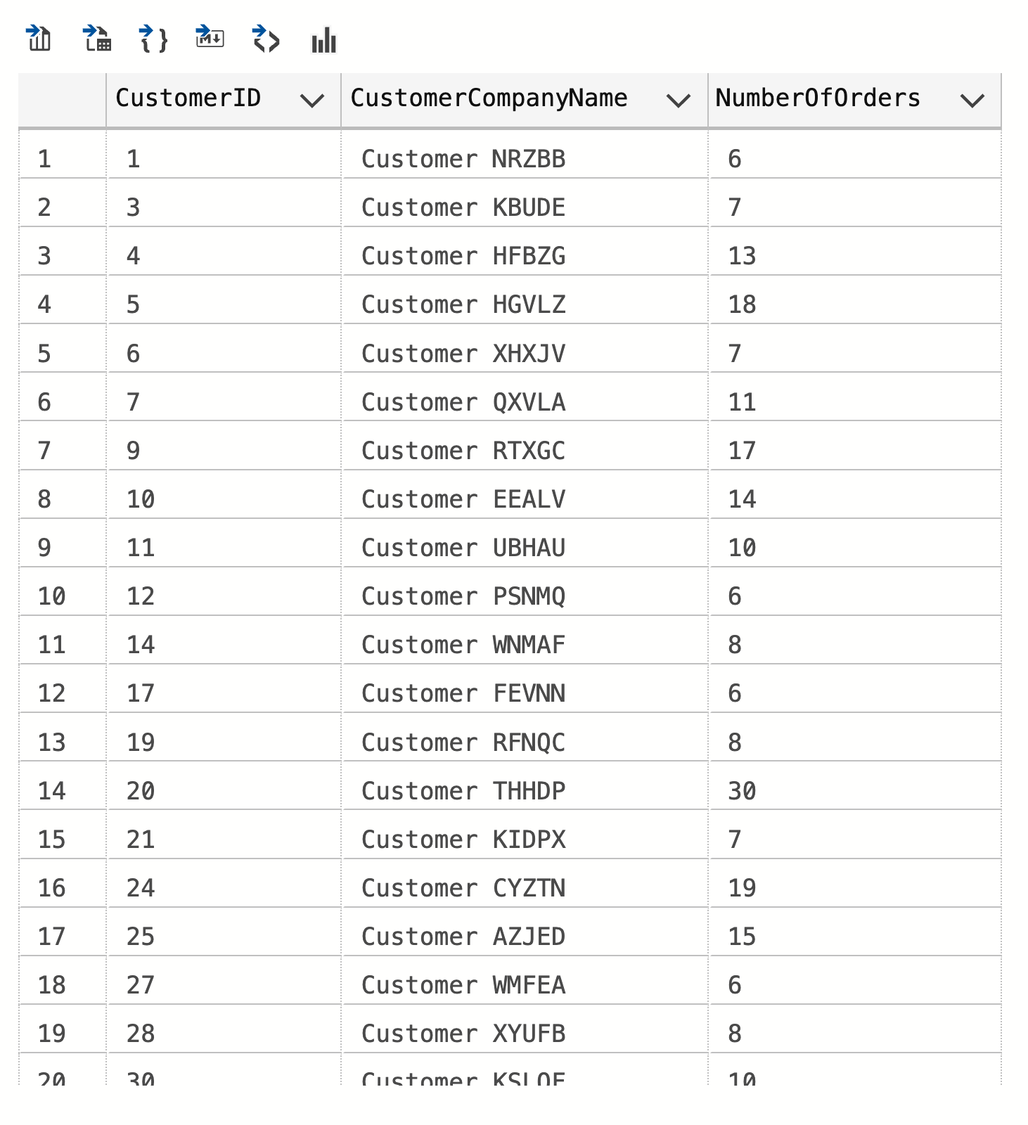

# 

# Sample JSON Output with total number of rows returned:

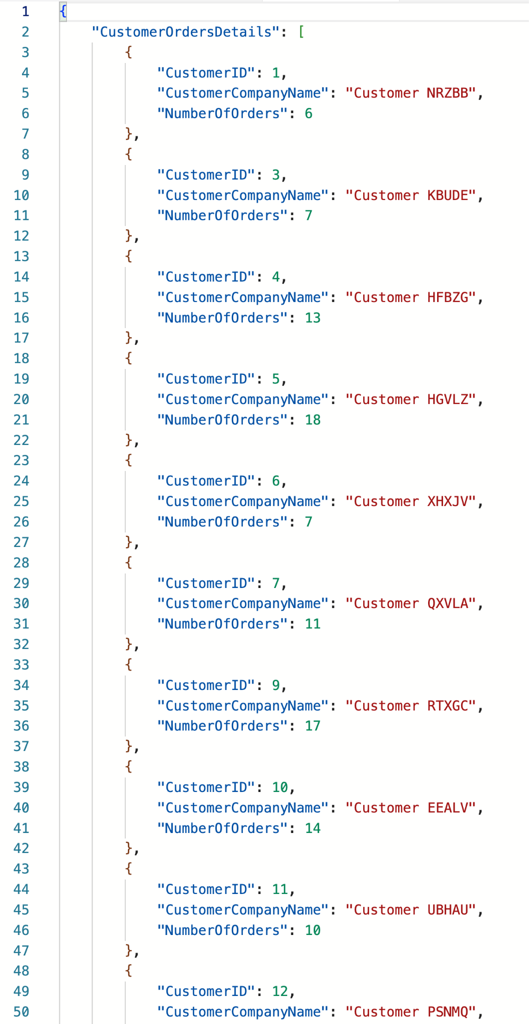

# TOP QUERY (2)

USE PrestigeCars;



PROPOSITION: Retrieve customer details with more than 5 orders.

# TOP QUERY (3)

USE Northwinds2022TSQLV7;



PROPOSITION: Calculate the average sales value per employee-customer pair within a specified timeframe using a user-defined function for average calculation.

# WORST QUERY (1)

USE AdventureWorks2017;



PROPOSITION: Write a query that retrieves each business entity's total email addresses and phone numbers.

# WORST QUERY (2)

USE Northwinds2022TSQLV7;



PROPOSITION: Aggregate total sales per customer by summarizing sales from all their orders.

# WORST QUERY (3)

USE AdventureWorksDW2017;

ER DIAGRAM

PROPOSITION: Retrieve the average sales amount by currency for orders placed in 2014, sorted by the overall average sales amount in descending order.

# REST OF MEDIUM (1)

USE Northwinds2022TSQLV7;



Proposition: Retrieve sales employee details with total orders since hiring after January 1, 2012, ordered by total orders in descending order.

# REST OF MEDIUM (2)

USE AdventureWorks2017;



Proposition: Retrieve average pay rates per department, including the number of unique positions in each, ordered by average pay rate in descending order.

# REST OF MEDIUM (3)

USE AdventureWorksDW2017;



Proposition: Write a query that calculates and retrieves the total sales by each employee in a specific fiscal year, ordered by the total sales in descending order.

# REST OF MEDIUM (4)

USE WideWorldimporters;

# ER DIAGRAM

Proposition: Retrieve detailed summary of purchase orders, including the latest receipt date for each order.

# REST OF MEDIUM (5)

USE AdventureWorksDW2017;



Proposition: Retrieve the total sales for each product sold in a specific sales territory during the year 2014, ordered by total sales in descending order.

# REST OF MEDIUM (6)

USE WideWorldimporters;

ER DIAGRAM

Proposition: Aggregate and report on the total quantities on hand for each purchase order, sorted by these totals in descending order.

# REST OF MEDIUM (7)

USE WideWorldImportersDW;

# ER DIAGRAM

Proposition: Analyze sales performance of stock items, focusing on total quantity sold and the most recent sale amount for each item.

# REST OF MEDIUM (8)

USE WideWorldImportersDW;

# ER DIAGRAM

# Proposition: Analyze the relationship between orders and movements by supplier and package, aggregating quantities and movement counts.

# 

# REST OF COMPLEX (1)

USE PrestigeCars ;

ER DIAGRAM

Proposition: Adjust total sales for tax based on the country using a user-defined function for tax adjustment, ensuring that sales data is accurately matched with the correct country information.

# REST OF COMPLEX (2)

USE AdventureWorks2017;



Proposition: Analyze sales and customer ratings across product categories, utilizing a user-defined function for average rating calculation.

# REST OF COMPLEX (3)

USE AdventureWorksDW2017;



Proposition: Categorize sales performance per product within sales territories using a user-defined function to determine sales categories based on total sales.

# REST OF COMPLEX (4)

USE AdventureWorksDW2017;



Proposition: Calculate net sales after applying geographical discounts for customers in the United States using a user-defined function for discount calculation.

# REST OF COMPLEX (5)

USE WideWorldimporters;

# ER DIAGRAM

Proposition: Apply supplier discounts based on total expected cost of orders placed in the year 2013.

# REST OF COMPLEX (6)

USE WideWorldImportersDW;

# ER DIAGRAM

Proposition: Analyze sales data for a specific period, calculating total and average sales per category with a user-defined function for sales amount calculation.

# 

# 